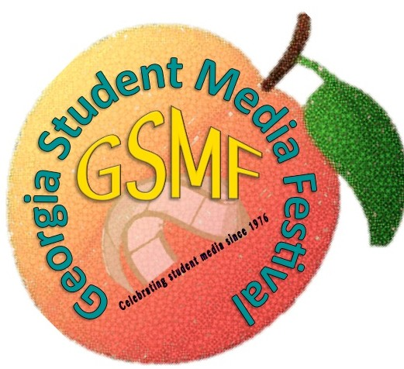
2017 GSMF Entry Guide

In classrooms across the globe, teachers and students are working together to infuse technology into their learning landscape. Since 1976, the Georgia Student Media Festival has supported and celebrated those
efforts.

K-12 festival activities progress through three successive levels: local, system, and state. Entries must be evaluated at each level and receive a superior rating in order to proceed to the next level. Private schools are responsible for contacting the public school system in their geographic area for information on system or state level judging. Home school students should check with local K-12 schools to find local school media festivals in which to participate.

We know that today’s students live in a technology rich world. Teachers and parents respond to this by finding ways to engage students in deep, rigorous, active learning through technology.

• For students of all ages, media projects—such as live action video, website design, and animation—foster learning across the curriculum.
• Reading comprehension, writing, research, and math skills are developed and strengthened; students utilize technology tools to create their own media to communicate and to interpret their ideas.
• Students increase their abilities to plan, analyze, and interpret results.
• Cooperative learning and leadership flourish where student media is encouraged.
• Georgia Standards of Excellence and national educational standards are met and surpassed in the exciting atmosphere of creativity cultivated through the use of student media projects.

In short – students who create their own media projects have fun while they are learning! They transform from passive recipients of information into active, engaged learners. What more could an educator want?

Whether you are new to the world of technology integration, or a master of infusing 21st-century skills into your learning landscape, the Georgia Student Media Festival has something to offer you.

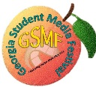
2017 GEORGIA STUDENT MEDIA FESTIVAL

Entry Rules

Eligibility of Participants: Participants must be students attending a public, private, home school, or parochial school in the state of Georgia.

Original Student Work: All entries must be original student work. Faculty or parent guidance and instruction are acceptable, but planning, production, and operation of equipment should be student work. The signature of the teacher/sponsor or the GAIT/GLA member on the Official Entry Form must certify that the entry is the work of the student producers. Entries may be the work of one student, a group of students, a class, or a student organization.
Parents of each student producer should complete and sign the GSMF Media
Release Form in order for the entry to be viewed on the GSMF website.

Copyrighted Materials: Any visual or audio material which is not student-produced must adhere to the Fair Use Guidelines for Educational Multimedia (found on the Fair Use page: http://www.gsmf.us/fair-use.html). Extended use of copyrighted material (e.g., more than 30 seconds of a song) requires written permission from the owner of the
copyright and must be enclosed with entry. |  | Include all citations and acknowledgements
at the end of each project making sure to list all sources of materials used (images,
music, videos, websites, books, etc.) | This is required whether citing material used under

Fair Use or with permission.

Student Identification: Please follow digital safety guidelines. If student producers are credited in the production itself, do not include the last names of students unless there is a release form signed by an authorized parent or legal guardian of the minor. You will need to provide the full names of all students and teachers who participated in creating the project on the GSMF entry form. Use back of form if needed.

Production Date: Any entry completed after the 2016 State Media Festival is eligible.

SUBJECT AND TREATMENT: For the State Festival, entries may deal with any subject or theme. The subject may be treated in any way. Examples include a story, a documentary, teaching unit, or simply as entertainment.

Projects will not be disqualified at the state level due to subject or content.

Language: All entries should be in English, if possible. If not possible, information in
English about the production must accompany the entry.

Online Availability: Website entries must be online and viewable via the Internet through August of the festival year. To assure access to submitted material, please include all login/password information. Links to sites, which were not created by the entrants, should be identified and will not be considered in the judging.

2017 GEORGIA STUDENT MEDIA FESTIVAL

SUBMISSION OF PROJECTS: Live Action, Animations, Interactive Stills, Sequential Stills (all types), Podcasts and Website entries MUST be submitted on CD or DVD. It is highly recommended that you test all entries on a device other than the one it was created on to ensure that project works as intended. Sponsors of entrants are responsible for assuring students are allowed to use the multimedia programs, such
as Prezi.

RATING CERTIFICATES: Every student will receive a certificate based on project scores.
Projects that receive a 100 at the state level will be recognized as Best of Show.

Participation: 80 - 89 Merit: 90 - 95 Superior: 96 - 100

Note: Only Superior winners will advance to the next level of the competition.

RETAINING ENTRIES: The Georgia Student Media Festival Committee reserves the right to retain entries after the State Festival and to make copies of or take excerpts from them for use in publicizing or reporting on the festival. Do not send master copies or your only copy of projects. Make a copy to keep for your records.

ENTRY PACKAGING AND LABELING: The system level coordinator or designated contact person is responsible for labeling each project with the system name, submitting the projects, and submitting the Registration Checklist at the state level by the
deadlines. Return postage or transportation to and from all levels of the Georgia Student
Media Festival must be provided by the system.

Entries must be properly packaged. SUBMIT ONLY ONE ENTRY IN EACH 9”X12” ENVELOPE. All entries must be clearly labeled with the official GSMF entry label. Please complete all information on the label and affix it to the upper left hand corner of the entry envelope. ALL PARTS OF THE ENTRY SHOULD BE LABELED AND STORED IN THE LABELED 9” x12” UNSEALED CLASP ENVELOPE.

Entry
Label
Front of
envelope
Include the following inside the envelope for each entry:
- completed entry form
- copyright compliance form, and/or documentation
- media release forms
- “About My project” form (*now required)
- site map (required for web pages only)
Do NOT include judging sheets or certificates from previous festivals.
Judging forms will be provided onsite.

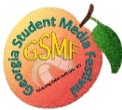

FESTIVALS
*Projects must arrive at Clayton State University THREE WEEKS PRIOR TO STATE FESTIVAL DATE.

STATE LEVEL JUDGES REQUIREMENT: At the state level of the festival, school systems submitting entries are requested to provide one judge for every ten (10) entries. For example, one (1) judge for any number of submitted projects ten (10) or less; five (5) judges for forty-one (41) through fifty (50) submitted projects.

2017 GEORGIA STUDENT MEDIA FESTIVAL

SYSTEM CONTACT PERSON: Each system that participates is required to send contact information for their designated contact person or the coordinator as most communication will be done via email. This person will be responsible for disseminating information to all participants in their system before, during, and after the festival.

Late entries will not be accepted. K-12 festivals should be conducted on or before these dates:

Festival Date
Building Level February 24, 2017
System Level March 24, 2017
State Level April 28, 2017

Student Registrations and Judges Registrations must be submitted online on or before April
7, 2017 using the http://www.gsmf.us site.

Projects must arrive at Liberty County School System Tech Office on or before April 7, 2017. (Attention Kate Gukeisen)

Send projects to:

State Student Media Festival Co-Chair:
ATTN: Kate Gukeisen
Liberty County School System Complete Registration online or Email
Tech Office Registration spreadsheet to:
200 Bradwell Street Ann V. Grantham: avgrantham@cox.net
Hinesville, GA 31313
912-876-4838
kgukeisen@liberty.k12.ga.us

State Student Media Festival Co-Chair: State Student Media Festival Co-Chair:
Michelle Lenderman Dr. Gordon N. Baker
Bibb County School District Dean of Libraries
Media Services Director Clayton State University
484 Mulberry Street, Suite 235 2000 Clayton State Blvd.
Macon, GA 31201 Morrow, Georgia 30260
478-765-8598 678/466-4334
478-952-0027(c) 678/466-4328
Michelle.lenderman@bcsdk12.net gordonbaker@clayton.edu

State Media Festival: April 28, 2017
Liberty County School System
Performing Arts Center
2140 East Oglethorpe Highway
Hinesville, GA 31313
912/877-0508

4

2017 GEORGIA STUDENT MEDIA FESTIVAL

Production Types

Audio Podcast: A podcast is a digital audio program that can be played on a computer or digital audio player. A podcast can be a stand-alone item or one of a series, though only one of the series should be submitted. Files should be in mp3 or mp4. RSS files are not required.
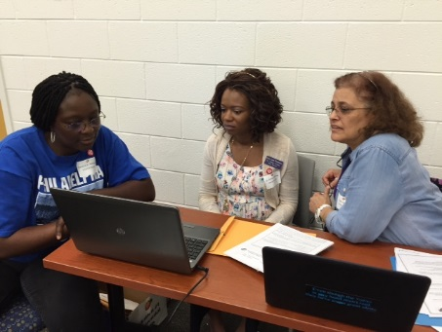
Live Action (includes Video Podcasts): Full motion productions such as dramas, comedies, documentaries, commercials, news shows, talk shows, interviews, instructional presentations, etc. These productions generally will have on- screen talent in the form of actors, instructors, hosts, and/or narrators. A computer may be used for title, credits and overlays, and may be used in the editing process. Such projects are still “Live Action”.

Animation: An Animation includes drawn images, clay models, and/or real-life models that are animated to create the illusion of movement. If a piece integrates live action and animation, it falls under the animation production type. Famous examples of integrated animation are the 1988 Who Framed Roger Rabbit or 1996 Space Jam.

Sequential Stills:
“Sequential Stills” is defined as a series of still images from slides, photographs, still video or digital images rendered into a production using photographic, electronic or computer technology, including Quicktime, PowerPoint, or similar computer programs. Text, music, video clips and/or narration may be added. The order that
the stills are viewed in is fixed by the producer. These are submitted on CD, or DVD.
*COMPLIANCE WITH SOFTWARE GUIDELINES IS EXPECTED.

a) Sequential Stills Regular – A series of still images from slides, photographs, still video or digital images rendered into a production using photographic, electronic or computer technology, including Quicktime, PowerPoint, or similar computer programs.
b) Sequential Stills Class Project – K-5 Only
This is a special form of Sequential Stills-Regular (see description above) where a teacher provides more guidance to the student(s). For example, entries are classified as Sequential Stills Class Projects when a teacher structures a template and the students produce the content. This production type is intended for younger students just learning how to create media projects.
c) Electronic Picture Book – These projects must be original student work that has been scanned into slideshow software or original student artwork that has been created on a computer and imported into some type of slideshow software. (An author page may include a commercially produced school picture of the student.)
d) Electronic Photographic Essay – These projects are a slideshow presentation that involves the organization of a number of original photographs on a single theme. Titles and captions may be used.

5

2017 GEORGIA STUDENT MEDIA FESTIVAL
Interactive Stills: An Interactive Stills production includes images that are viewed in an order chosen by the viewer. Interactive Stills use navigation buttons and/or menus to enable the viewer to select a path. Text, music, video clips and narration may be incorporated into an Interactive Stills production.

Website: All URL addresses must be available for download from the Internet, but due to technological uncertainties all website entries must include a backup CD or DVD. To assure access to submitted material, please include all login/password information. Important note: A “site map” must be included inside the project envelope. (It may be in either a flow chart or table of contents format that gives the judges information on bringing up the website

Purpose of Production

Instructional: The purpose of an instructional piece is to teach. Excellent entries in this category go beyond simply presenting facts. Examples include: tutorials, teaching tools, and interactive games with assessment.

Informational: The purpose of an informational piece is to present a factual view of a topic or issue, without the bias of persuasion or opinions. Informational pieces may briefly cover multiple topics or choose to focus on one or two. Examples include: news programs, biographies, community calendars, and personal websites.

Documentary: The purpose of a documentary is to convey an actual event or topic beyond the scope of a typical news story. It should reflect serious research and present facts objectively without fictional matter.

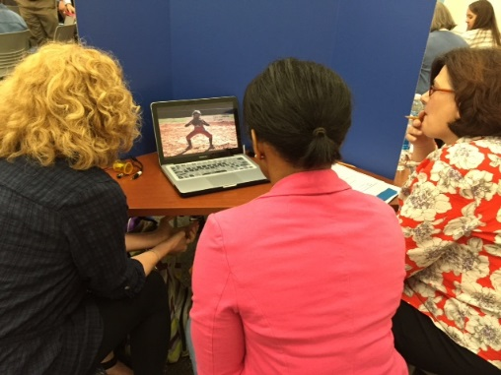
Persuasive/PSA: The purpose of a persuasive piece is to present an idea, product, concept, organization or individual in a credible way, so as to change public opinion and/or encourage audience approval, support or participation. Examples include: Advertising, Public Service Announcements, and Movie Trailers. Public Service Announcements (PSAs) are 30 to 60 second messages designed to change public opinion, actions, or feelings.

Story: The purpose of a story piece is to tell a story, whether serious or lighthearted, fictional or
non-fictional. Examples include: comedies, dramas, and student/family experiences.

Entertainment: The purpose of a piece in this category is to entertain and/or amuse the audience in a format other than telling a story. Examples include: music videos, variety shows, interactive games, and game shows.

6

Specifications

Copyright: Any visual or audio material which is not student-produced must adhere to the Fair Use Guidelines for Educational Multimedia (found on the Fair Use page: http://www.gsmf.us/fair-use.html) . Extended use of copyrighted material (e.g., more than 30 seconds of a song) requires written permission from the owner of the copyright and enclosed with entry. Include at the end of each project listing sources of materials used (images, music, videos, websites, books, etc.) whether citing material used under Fair Use or with permission.

Length of Production: Entries may be as long as producers deem fit. Judges will view as much of the entry as needed to ensure a fair appraisal of the work (typically 7 minutes). We suggest that you place credits at the end of the production.

Divisions/Grade Levels: Sponsors will indicate the grade level of the oldest member of the production team.

Production Teams: Entries may be produced by an individual student, a group, a class, or a club. The entry submission should include the names of all students and teachers who participated in creating the project. This ensures we provide certificates to all participants in the required 9”x 12” clasp envelope.

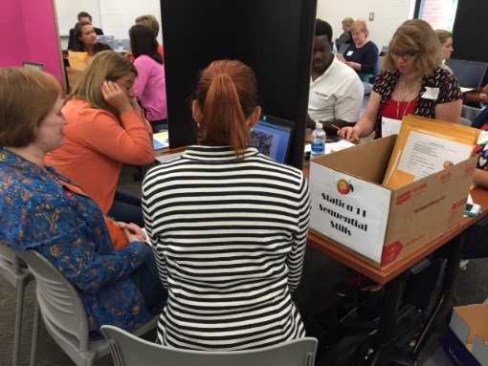
About My Project Form: GSMF judges feel they can make a better evaluation of a media project if they have some background information and understand the project from the students’ point of view. The student will have the opportunity to provide answers to the following questions for each project:

• What inspired you to create this project?
• Describe the steps you took to create your production. (How long did it take you to create?)
• What would you like the judges to know about this project?
• What challenges to creating your project did you have, if any?
• What have you learned from producing this media project?

Entry Media and Delivery: It is highly recommended that you test your entry, using a device other than the one used for production and outside your school network. Students are encouraged to view web pages online after they have been uploaded to
confirm there were no errors introduced through file conversion and transfer. The GSMF
is not responsible for lost, damaged, or non-functioning entries. Projects can be picked up after all entries are judged.

Never send your masters or the only copy of CDs, DVDs or USBs.

System/Project Sponsors should certify the following:

• The entry is original student work.
• I have the authority to enter the above-noted piece in the Georgia Student Media Festival and have obtained in writing the right to make the grants contained in this entry form, including but not limited to, the copyright and other intellectual property rights therein, from the student(s) who created the work.
• The visual and/or audio material in this production is student produced and adheres to the Fair Use Guidelines for Educational Multimedia unless otherwise specified. I understand unreleased copyrighted material found in the media project will not
be judged.
• GSMF representatives have permission to make copies of the entry for festival viewings, fundraising, and promotion, as GSMF deems appropriate with a signed Media Release form. This may include, but is not limited to, print, electronic, and broadcast distribution.
• In the event that GSMF is rendered liable for any damages which result from any
breach of the above representations and warranties, then I will hold GSMF harmless from and against such liability, including all reasonable attorneys’ fees incurred at arbitration, or any trial or appeal.

Judging Feedback: GSMF is unique in our commitment to providing constructive feedback to student producers. Our volunteer judges believe educational comments help the students hone their media production skills. Feedback for each project judged will be provided.

We especially liked... | the way you used different points of view. I learned a lot about paper and am pretty sure I can make my own now.
You did a great job with... | the way your audio set the mood. I was really scared during the chase scene.
Next time you may want to... | make the words easier to read with a larger font.

Criteria for Scoring

A. Content and Organization (All Production Types)

Creativity/Originality | Provides fresh, meaningful & interesting insights into the subject of the production.
Emotional  Impact/Attitude | Heightens viewer attention and interest. Touches human emotions or feelings. Has a strong effect. Most podcasts should have a professional serious attitude throughout (Humor is great, but just being silly, isn’t).
Organization | Shows a clear and obvious planning through all parts of the production.
Continuity/Structure | Shows that the information or story is paced and developed in a way that keeps viewers interested and helps them understand the meaning.
Purpose | Achieves its stated purpose.

B. Technical Quality

Audio  (All with sound) | Background music and sound effects (if present) balance with speaking voices, and are appropriate to content. There is a minimum of hiss or extra noise.
Vocal Quality  (All with narration) | The vocal performers speak clearly, and at an appropriate speed. They are  lively and enthusiastic.  Speaking voices are clear and easy to understand.
Editing/Transitions  (Podcasts, Live-Action Video, Sequential Stills | Scene changes are smooth and appropriately placed. Cuts/transitions used are appropriate and do not distract the audience. Images (if included) are appropriate, easily understood, and add useful information.

Timing/Flow/Synchronization (All) Fluid Movements (animation) | The narration and visuals move at a suitable pace. Length is right for the amount of information (not too short, not too long).  Animated objects move smoothly.
Visual/Emotional Impact (All productions except podcasts) | Heightens viewer attention and interest. Touches human emotions or feelings.  Has a strong visual effect.
Grammar/Punctuation/Spelling  (All with text or audio) | Onscreen text is correct (taking into account the grade of the producers).
Focus/Lighting (All productions except podcasts) | The image is clear and the lighting is appropriate for the desired mood.
Camera Techniques (All productions using cameras) | The angle of the shot is effective in showing the subject and action appropriately. A tripod was used if it was needed.
Composition/Clarity/Color (All productions except prodcasts) | The elements within a scene (the main subject, supporting subjects, foreground and background) are arranged in a pleasing way. The images, graphics, and fonts are clear. The color palette and the contrasts between dark and light are appropriate for the desired mood.

C. General Effectiveness

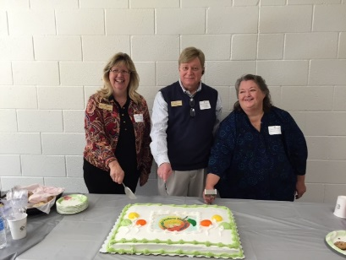
An overall evaluation of the production based on the above criteria combined with the considered judgment of the evaluator.

GSMF GALILEO Staff Award:

In order to promote recognition of both resources available to students in GALILEO and of students’ adoption and use of GALILEO resources in their projects, GALILEO offers an award for the best use of GALILEO resources in a project submitted to the Georgia Student Media Festival. In addition to the recognition, the award provides a technology-oriented incentive. In this way, the award will provide direct benefit to the Festival, teachers, and students, further the collaboration between GALILEO and the Festival organizations, and highlight the benefits of GALILEO to the shared community of interest. Criteria includes integration of GALILEO content into the project, including GALILEO in the citations, and evidence that database research was included in the project.

For additional information, please visit the Georgia Student Media Festival website:

http://ww w.gsmf.us
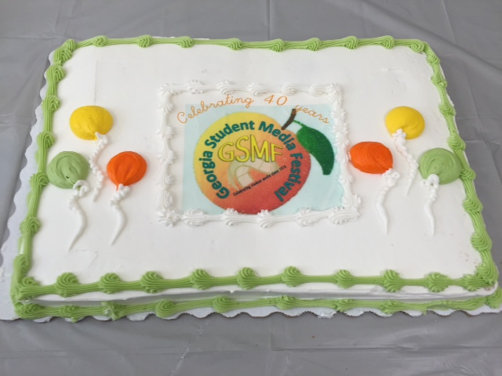

2017 GEORGIA STUDENT MEDIA FESTIVAL

Sponsored by:

The Georgia Association for Instructional Technology
http://www.gait-inc.org/

The Georgia Library Association
http://gla.georgialibraries.org/

in Partnership with Georgia Public Broadcasting

http://www.gpb.org/

and the Clayton State University Library
http://www.clayton.edu/library

‘

*The information in this booklet is current as of September 2016.

12

